Cruise Report

Eco-FOCI Fall Moorings

Cruise AQ2018-01

R/V Aquila

September 29 – October 12, 2018

Geoff Lebon

Dave Kimmel

Peter Proctor

Catherine Berchok

**Scientific Staff**

Geoff Lebon PMEL/FOCI/JISAO

Peter Proctor PMEL/FOCI/JISAO

Matt Wilson ASFC/FOCI

Dave Kimmel AFSC/FOCI

Catherine Berchok AFSC/MML

Sarah Donohue PMEL/FOCI/NOAA Corps

Annabel Mathiske FOCI/Intern

Hilary Kates Varghese Univ of New Hampshire

Jessica Kimber AFSC/MML/JISAO

David Strausz PMEL/FOCI/JISAO

**Cruise Objective:**

The primary objective of cruise AQ18-01 was the recovery of the surface moorings at M2 followed by the turnaround of moorings at sites M4, M5, M8 and recovery of moorings off of Saint Mathew Island. The CTD/Bongo boxes around each of these sites were next in line followed by the marine mammal mooring turnarounds and the 72 m isobath stations. The lowest priority was the DBO1 line.

**Operations:**

The operations consisted of 4 main categories, moorings, ctd’s, bongo/CalVET tows, and marine mammal ops.

**1) Moorings**, Geoff Lebon, David Strausz, Catherine Berchok, Hillary Kates-Varghese:

Mooring operations for AQ18-01 consisted of 13 moorings recovered with another attempted recovery and 12moorings deployed. These included 4 ADCP (Acoustic Doppler Current Profiler) moorings turned around, 1 passive acoustic mooring turned around and 1 deployed, 3 physical oceanographic moorings turned around and one deployed, 2 ice popup moorings deployed, and 2 surface moorings recovered. All mooring operations were performed without incident or damage to any instrumentation. One ADCP mooring had to be recovered by attempted dragging as the release failed to operate properly. Upon being hit by the drag wire the release functioned properly. A complete list of all instruments attached to each mooring is listed in the tables below.

**Moorings recovered**, ADCP = Acoustic Doppler Current Profiler; Eco=flourescence; SeaCat=conductivity, temperature, depth; MicroCat=conductivity, temperature, depth; Optode=oxygen sensor; SBE Temp=temperature sensor; AURAL=passive acoustics; AWCP=fish finder; PAL=passive acoustics; CPOD=echolocation.



**Moorings deployed**, ADCP = Acoustic Doppler Current Profiler; Eco=flourescence; SeaCat=conductivity, temperature, depth; MicroCat=conductivity, temperature, depth; Optode=oxygen sensor, SBE Temp=temperature sensor; AURAL=passive acoustics; AWCP=fish finder; PAL=passive acoustics; CPOD=echolocation.



**2) CTDs,** Peter Proctor and Dave Strausz:

The CTD objective for the cruise was to perform CTDs along the 72m isobath from the M2 mooring site up to the M8 mooring site to continue long term monitoring of the Bering Sea Ecosystem. With weather considerations forcing operations, the M2, M4, and M5 boxes were completed. The 72 m isobath stations between M4 and M5 were targeted due to those being missed on the spring cruise and with oncoming storms, only 2 bongo stations were occupied between M4 and M5.

After the M5 box was complete, bongo stations between M5 and M8 were occupied until weather and the loss of the starboard engine forced the vessels departure to the M8 moorings. The M8 box was not occupied due to oncoming weather and the loss of one engine. The DBO1 line was not attempted due to time and weather. The table below summarizes the sampling taken at each station with a final tally for samples being 26 CTD’s total, 12 Salinities, 184 nutrients, 25 oxygen, 164 chlorophyll, and 12 DIC.

**Summary of all CTD Sampling for Cruise AQ18-01**

|  |  |  |  |  |  |  |  |  |  |
| --- | --- | --- | --- | --- | --- | --- | --- | --- | --- |
| CTD # | Site | Staiton Number | No. of Nutrients | Salinity Samples | Oxygen Samples | Chlorophyll Samples | Number of DIC | DOP/DON Sample | Ladd Sample |
| CTD001 | M2 | 1 | 9 | 1 | 2 | 9 | 1 |  |  |
| CTD002 | M2C | 2 | 4 |  |  | 3 | 3 |  |  |
| CTD003 | M2C | 2 | 4 |  | 1 | 8 |  |  |  |
| CTD004 | M2S | 3 | 8 |  | 1 | 6 |  |  |  |
| CTD005 | M2W | 4 | 8 | 1 |  | 6 |  |  |  |
| CTD006 | M2 | 5 | 8 |  | 1 | 6 | 3 |  |  |
| CTD007 | M2E | 6 | 7 |  | 1 | 6 |  |  | 1 |
| CTD008 | M2N | 7 | 7 | 1 | 1 | 6 |  | 1 | 1 |
| CTD009 | M4E | 8 | 7 | 1 | 1 | 6 |  |  |  |
| CTD010 | M4N | 9 | 7 |  | 1 | 6 |  |  | 1 |
| CTD011 | M4W | 10 | 7 |  | 1 | 6 |  |  |  |
| CTD012 | M4S | 11 | 7 | 1 | 1 | 6 |  | 1 |  |
| CTD013 | M4C | 12 | 7 |  | 1 | 8 |  |  |  |
| CTD014 | 70M26 | 13 | 7 |  | 1 | 6 |  |  |  |
| CTD015 | 70M30 | 14 | 7 | 1 | 1 | 6 |  |  |  |
| CTD016 | M5C | 15 | 9 |  | 1 | 8 |  |  |  |
| CTD017 | M5E | 16 | 7 | 1 | 1 | 6 |  | 1 |  |
| CTD018 | M5S | 17 | 7 |  |  | 6 |  | 1 |  |
| CTD019 | M5N | 18 | 7 | 1 | 1 | 6 |  | 1 |  |
| CTD020 | M5W | 19 | 7 |  | 1 | 6 |  | 1 |  |
| CTD021 | 70M42 | 20 | 7 | 1 | 1 | 6 |  | 1 |  |
| CTD022 | MT-3A | 21 | 5 | 1 | 1 | 5 |  |  |  |
| CTD023 | 70M44 | 22 | 7 |  | 1 | 6 |  |  |  |
| CTD024 | 70M46 | 23 | 7 | 1 | 1 | 6 | 1 |  |  |
| CTD025 | 70M48 | 24 | 7 |  | 1 | 6 |  | 1 |  |
| CTD026 | M8C | 25 | 9 | 1 | 1 | 8 | 3 |  |  |

**3) Bongo/CalVET tows**, Dave Kimmel, Matt Wilson, Annabel Mathiske:

Zooplankton samples and water profiler data were collected simultaneously at 22 sites.  These sites were along the 70-m isobath (6 sites), at and around the M2, M4, M5, and M8 moorings (16 sites. At each site, a bongo-profiler array was used to sample from the sea surface to 10 m off bottom. Samples were collected with a 20-cm bongo (153-µm mesh) and a 60-cm bongo (505-µm mesh) net on the wire just below a Sea-Bird Electronics Fastcat profiler (SBE-49). The profiler was used to indicate net depth in real time and measured temperature and salinity.  Net 1 of each bongo net (20 and 60 cm) was preserved (5% formalin-buffered seawater solution) for quantitative analysis. Both Net 2 samples were used for Rapid Zooplankton Assessment (RZA, RCountZ) at 4 stations and were preserved (5% formalin-buffered seawater solution) at 20 stations for a student intern project (Annabel Mathiske). Finally, both Net 2 samples were preserved in 100% ethanol for genetic analysis by Carol Stepien at 2 stations. At mooring sites M2, M4, and M5 a California Vertical Egg Tow (CalVET) net (53-µm mesh) was used, along with the profiler, to collect triplicate samples of microzooplankton from the upper 60 m of the water column.

Table 1.  Bongo and CalVET tow sample totals

|  |  |  |
| --- | --- | --- |
| Samples Collected | Tows | Number |
| Zooplankton sample for Dave Kimmel and Annabel Mathiske | 40 | 40 |
| Genetic sample for Carol Stepien | 4 | 4 |
| Quantitative tow preserved in formalin | 53 | 53 |
| Rough Count Zooplankton for Rapid Zooplankton Assessment | 8 | 8 |
| Gears Used |  |  |
| 20BON - 20cm bongo | 22 |  |
| 60BON - 60cm bongo | 22 |  |
| CALVET - CalCOFI vertical egg net tow | 9 |  |
| CAT - Seabird SeaCAT CTD | 31 |  |

**4) Passive Acoustics Marine Mammal Ops**, Catherine Berchok and Brynn Kimber

Passive Short-term passive acoustic monitoring was conducted opportunistically through the deployment of sonobuoys approximately every three hours as water depth and other ship operations permitted. Sonobuoys are short-term, expendable, listening devices which transmit the acoustic signals via VHF to an antenna on the ship. The distance from the ship to the sonobuoys was around 10 nm (with tuned Morad VHF antenna). A total of 77 sonobuoys (all 53F) were deployed and 65 transmitted signals for a success rate of 84%. The species detected were fin, killer, humpback, and North Pacific right whales (NPRWs), and walrus (Figure 1). Fin whales were the most commonly detected (on 26 of the successful sonobuoys (40%)), followed by NPRWs on six buoys (9%), and humpback and killer whales and walrus on two or less sonobuoys each (&lt;3%). The detection of the killer whales on 30 Sep 2018 was accompanied by a visual sighting of 9 residents who were bow riding the vessel (photographs available and being matched to the catalog). Although the sonobuoy was deployed well before the sighting, calling was not detected until the end of the encounter, however. There is also the potential that a NPRW was spotted by the Captain on 1 Oct 2018, in the vicinity of sonobuoy #10. However, the whale never surfaced again for confirmation of identification. There was no marine

mammal watch, and so all sightings were opportunistic. In addition to the two mentioned here, a

humpback whale was sighted on 11 Oct 2018 and a poor fluke photograph taken, and several walrus, sea otters, and northern fur seals were spotted without being noted in the sonobuoy log.

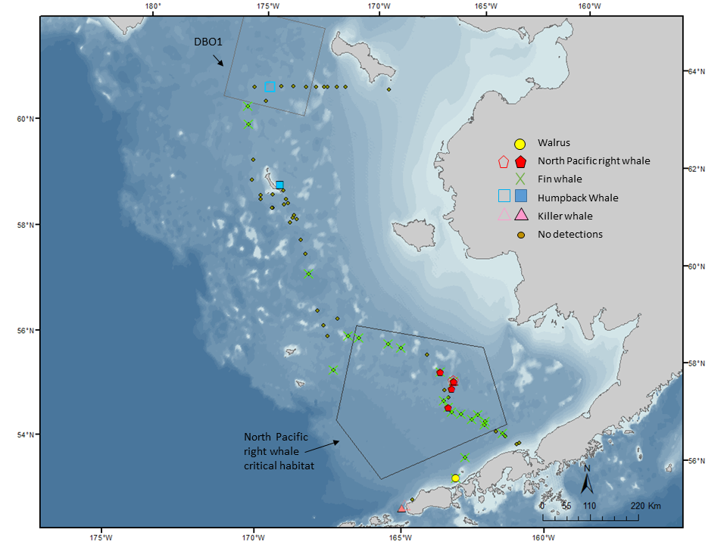

Figure 1. Sonobuoys successfully deployed during AQ18-01 and species detected. Small open symbols are visual sightings made opportunistically (NPRW was not confirmed).

**Summary**: The 2018 fall mooring cruise was originally scheduled to take place aboard the NOAAs Oscar Dyson. Due to mechanical difficulties the Dyson was not able to sail and the cruise was transferred to the R/V Aquila. This allowed the Aquila to be loaded and outfitted in Seattle but pushed the date of departure from Dutch Harbor back 8 days to the 29th of September.

The Aquila departed Dutch Harbor on schedule on the 29th of Sept. The vessel proceeded to mooring site AL17_AU_BS4 later than expected due to delayed flights into Dutch Harbor but was able to turn this mooring around nearly on schedule. The next site was the M2 mooring site but due to rough weather the vessel stayed close to Unimak Island up to Amak Island before darting out to turn around all of the moorings at the M2 site. It should be noted that the BSM2A mooring was not at the M2 site but was found drifting 20 miles north of the M2 site and was recovered at that position. Upon completion of the M2 moorings, the vessel headed to Port Moller to wait out an approaching storm.

After waiting out the storm over the Bering Sea for over two days the Aquila departed Port Moller for the M2 site to sample the M2 box. After completion of the box, it was decided to forgo the 72m isobath stations between M2 and M4 to make faster progress before the next approaching storm with the objective to occupy the bongo stations on the isobath line between M4 and M5. Mooring site AU_BS3 was occupied on the way to M4 to turn around an acoustic mooring. The mooring was found to be missing and after deployment of the 2018 mooring for this site the vessel moved to mooring site M4.

After completion of the M4 moorings and the surrounding box, the Aquila started working up the 70 m line to M5 doing every other bongo station hoping to make it to M5 before the next round of wind set in. At the last bongo station before the M5 box, (70M34), the weather conditions had deteriorated to a point that the CTD cast was aborted and the Aquila made her way to a safe anchorage at Saint Mathew Island. On the trip up the line, acoustic mooring AL17_AU_BS2 was not recovered due to the approaching weather and its replacement was deployed near the line at new mooring station AL18_AU_BS9.

After a full day at anchorage the vessel departed to start on the M5 box and to turnaround the moorings at M5. This was accomplished in a timely manner and the vessel moved up the line to recover the Saint Mathew Island moorings and to occupy the bongo stations along the 70m isobath up to M8. Soon after the recovery of mooring 18MTP-1A, the vessel shut down the port engine for repairs but continued up the line on the starboard engine. During the night the scientific party was notified that the port engine would not be coming back online due to a lack of parts. Soon thereafter, with another high wind event approaching, the vessel abandoned finishing the line after completing station 70M48 and headed straight to the M8 box with the hope of being able to occupy the stations at the M8 box and to turn around the moorings.

During the night due to the slow progress of the vessel and with winds increasing on the bow, the Aquila was diverted straight to the mooring site vs the previous target of station M8W. At the mooring site, mooring 17BS8A was recovered but 17BSP8A would not release. Dragging operations were commenced on one engine and marginal weather and while the mooring was hooked for a while it did not come up. Upon again sending the release codes, the mooring surfaced and all M8 moorings were turned around. The bongo and ctd operations at M8 were completed but the CalVETS were cut due to approaching increasing winds and no port motor. Acoustic mooring AL17_AU_BS1 was also left in place due to time constraints and arrangements were made for the USCG Healy to pick up this mooring which they successfully did.

The vessel was able to dock in Nome at 6pm on the 13th of October with all but one scientist having bookings on the 8pm flight out of Nome.

The cruise was severely hampered by bad weather during its entirety and nearly 6 days of total science time was lost due to weather conditions with a little of that due to the slow progress made by the vessel on one engine between stations M5 and M8. While the vessel had only one engine during the M8 mooring operations, it should be noted that the shiphandling capability exhibited by the Aquila’s crew was far above what would normally be expected on a research vessel. As a final note, while some equipment repairs were required during the cruise which were normally accomplished while hiding from weather, no science time was lost due to equipment failure.